Repair and Leasing Scheme
The Repair and Leasing Scheme is an opportunity to bring vacant houses or commercial properties back into use as homes for families and individuals on the social housing waiting list.

Suitable buildings are typically located in central locations or are in high profile sites that benefit from renovation. Some key areas of interest for Kildare County Council are
- Athy
- Celbridge
- Kilcock
- Kildare Town
- Leixlip
- Naas
- Newbridge
- Maynooth
- Monasterevin
Under the Repair and Leasing Scheme, the local authority or an Approved Housing Body (AHB), will provide interest free funding of up to €80,000 (including VAT) per individual home delivered, to bring the property up to rental standard. In return, the homes are leased to the local authority or an AHB for between 5 and 25 years. The loan is repaid via a deduction in the monthly rent over an agreed term within the lease.

What is RLS and what funding is available?
• RLS provides social housing through the renovation of vacant privately owned properties.
• Kildare County Council or an approved housing body (AHB), provides a loan to carry out works on vacant properties to bring them up to rental standards.
• The renovated home is leased to Kildare County Council or an AHB to provide social housing for between 5 and 25 years.
• The maximum loan is €80,000, including VAT, per completed unit; 2 units max €160,000, 3 units max €240,000 etc.
• The loan is offset against the monthly lease payment to the owner.
• Income – lease payments maximum 80%/85% of market rent for long-term leases or 92%/95% for RAA, less offset.

Benefits to Property Owner
• Long-term lease option (5 to 25 years) or Rental Availability Agreement (5 to 10 years typically).
• Kildare County Council or the AHB is the landlord to the tenant; no day to day maintenance (long-term lease only).
• No loss of rent during vacant periods; no advertising/letting fees.
• Guaranteed income for lifetime of lease.
• Interest free loan up to €80,000 including VAT, per unit, for example, where a vacant pub is converted into 7 units, maximum funding of €560,000 is available. In the case of multi-unit developments, funding may be apportioned between units.
• There is no limit on the number of units one property owner can provide under RLS.
• Tax relief under the Living Cities Initiative may apply, where appropriate (provided that all other requirements of the Initiative are met).

What properties qualify?
• Properties must be vacant for at least 12 months; and
• Kildare County Council must decide that the units are required and suitable for social housing.

Where can I apply?
If you are interested in applying to this scheme or wish to discuss, please contact us at vacanthomes@kildarecoco.ie

Further information on the Repair & Leasing Scheme is available here: https://www.gov.ie/en/publication/d32c4-repair-and-leasing-scheme-rls-fu...
Further information on the Living Cities Initiative is available here: Living City Initiative (LCI) (revenue.ie)
Information on the tax treatment of RLS is available on the website of the Revenue Commissioners.

Repair and Leasing Scheme Pathway

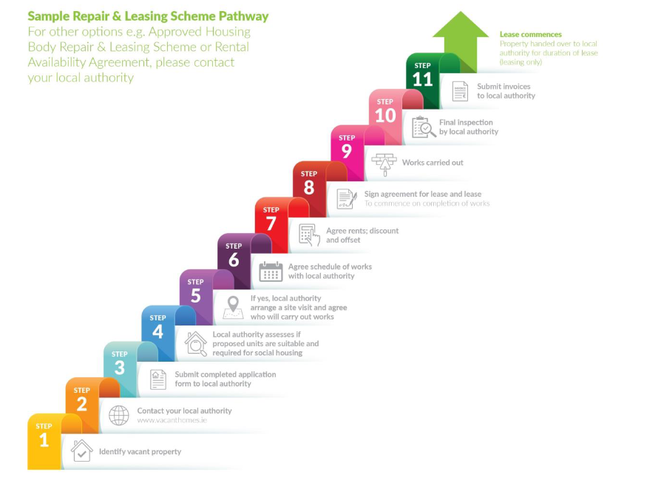

¹ S.I. No. 137/2019 - Housing (Standards For Rented Houses) Regulations 2019 (irishstatutebook.ie)

